**Electronic Supplement for Shelton et al.**

**Wave exposure calculations**

Finally, we calculated an exposure metric for each site, which was a composite of potential wind driven wave energy, to use as an explanatory variable in statistical models (see wave supplement for specific details). We used the waves tool (Rohweder et al. 2012) in ArcGIS to create a gridded surface of potential wave exposure for the length of coast represented across the study sites. We ran the model on a 30-m grid extending from the coastline out to 1,000 km. We used the NOAA Continually Updated Shoreline Product (CUSP) shoreline for the United States as the boundary for the land-sea interface (https://shoreline.noaa.gov/data/datasheets/cusp.html; accessed 19 September 2017). We ran the model using the SPM-Restricted method, which calculates wind fetch using the average of five radials spread three degrees apart (Smith 1991). We used the weighted fetch option in the waves tool, with probabilistic wind direction inputs derived from 1981-2010 normal hourly wind direction data for the Quillayute State Airport (Arguez et al. 2010). Finally, we overlaid study site points with the resulting weighted wave exposure grid and extracted the corresponding grid cell values.

Table S1: A summary of benthic invertebrate survey Survey description in table form.

|  |  |  |  |
| --- | --- | --- | --- |
|  | Survey methods. | Number of replicates | Area surveyed per site (m2) |
| 1987 | 1.0m2 quadrat by SCUBA, all counts conducted *in situ* | 100 per site. Not randomly placed locations | 100 |
| 1995 | 0.25m2 quadrat by SCUBA using video | 14-35 per site | 3.5-8.75 |
| Counts done by post-processing video. Most of the locations with video collected were not actually processed. |  |  |
| 1999 | 0.25m2 quadrat by SCUBA using video | 30 per site | 7.5 |
| 25 x 1m video transects | 3-4 per site | 75-100 |
| 2015 | 30 x 2m transects by SCUBA | 4 per site | 240 |

Table S2: Sites and the years they were sampled.

|  |  |  |  |  |  |
| --- | --- | --- | --- | --- | --- |
|  | 1987 | 1995 | 1999 | | 2015 |
| **Sites** | Quadrats | Quadrats | Quadrats | Transects | Transects |
| Neah Bay | X  (2 distinct sites) | X | X |  | X |
| Chibahdel Rocks |  |  | X |  | X |
| Cape Flattery |  | X | X | X |  |
| Tatoosh Island |  | X | X | X | X |
| Makah Bay | X | X | X | X |  |
| Anderson Point | X | X | X | X | X |
| Point of the Arches | X | X | X | X | X |
| Cape Alava | X | X | X | X | X |
| Cape Johnson | X | X | X | X | X |
| Rock #305 | X | X | X | X | X |
| Teahwhit Head | X | X | X | X | X |
| Destruction Island |  |  | X |  | X |

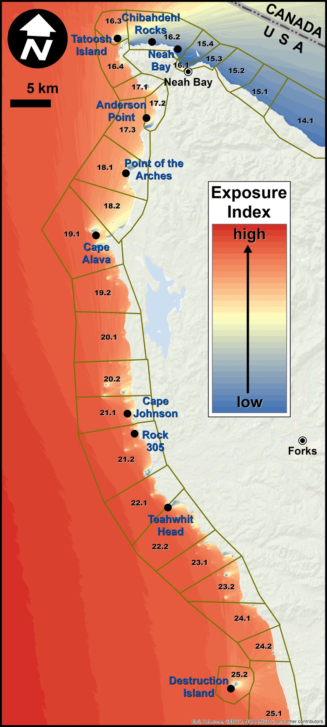

Figure S1. Map of predicted wind direction weighted wave exposure index for study region.



Figure S2: Kelp area CV for two periods (1989-2001 and 2002-2015) as a function of the mean number of otters during each period. Points represent bootstrapped means and 95% intervals. Individual sites are connected with dashed lines.

**Listed of methods for calculating wave exposure along OCNMS**

Used Waves (Rohweder et al. 2012) Tool in ArcCatalog

Used “Fetch Model” tool to calculate fetch distances for each of the 30m grid cells.

1. ArcToolbox -> Waves (2012) -> Fetch Model
2. Land/Water Interface Polygons
   1. Created custom Lambert Azimuthal Equal Area projection to conserve area
   2. Don’t need detailed coastline for areas outside study regions, just need general coast for calculating fetch
   3. Used CUSP shoreline starting at  44.617822° N lat (Yaquina Bay), ending at -122.753876° W lon/48.144213° N lat (Point Wilson)
   4. Used heavily modified GSHHS_h_l1 polygons for Puget Sound, BC, Vancouver Island and SE AK
   5. Used GSHHS_i_l1 for coast south of Yaquina
   6. Created 1000 km geodesic buffer using vertices from C:\aifiles\Ecosystem_Sci\Sea_otters\Distance_Matrix\CUSP_shoreline_sp_m.shp
   7. NOTE: Do NOT use wave exposure predictions for shoreline not included in this stretch, which starts at -124.236978°/47.283499° (~Point Grenville) and ends at -123.962343°/48.164818° (~just west of West Twin River mouth), as it will not extend fetch distances to a maximum of 1000 km.
   8. Did a union on 1000 km buffer of shoreline polygon with the composite land polygon shapefile and did extensive editing of features to create modeling surface for waves tool
   9. Merged all island polygons ≤2 m2 with water polygon
   10. Exported to ARC/INFO coverage to repair topological errors and created regular rectangle around area
3. Land/Water Raster = C:\aifiles\Ecosystem_Sci\Waves\hybrid_land (USGS DLG shoreline in USA and NASA shoreline for Canada)
   1. Land = 10
   2. Water = 0
   3. Make sure water grid cells are always completely contained by land, i.e., when you get to the boundary of the grid, there have to be land grid cells there.
4. Calculation Method = SPM-Restricted
5. Output Workspace = C:\aifiles\Ecosystem_Sci\Waves\wave_runs_new
6. Calculate Weighted Fetch = Checked (yes). Used Quillayute_Wind_dir_probabilities.csv, which is based on “normal” hourly wind direction and velocity data for Quillayute State Airport, based on data from 1981-2010.
   1. Arguez, A., I. Durre, S. Applequist, M. Squires, R. Vose, X. Yin, and R. Bilotta. 2010. NOAA's U.S. Hourly Climate Normals (1981-2010): Wind Speed and Direction. NOAA National Climatic Data Center.
   2. https://www.ncdc.noaa.gov/cdo-web/datasets/NORMAL_HLY/stations/GHCND:USW00094240/detail
   3. http://gis.ncdc.noaa.gov/map/viewer/
   4. STATION = USW00094240 (QUILLAYUTE STATE AIRPORT)
   5. Accessed 6 October 2017
   6. Completeness Flag: Vast majority were either "C" or "S"
   7. Data come in weird format where the mean wind information is presented for each hour of each day for one year (8687 data points) but the year is listed as 2010.  Ignore the year because it represents the mean wind data for any given hour on any given day based on data from 1981 - 2010.
   8. Used data from the “Mean wind vector direction (HLY-WIND-VCTDIR)” column
   9. Want to bin direction data in 10° increments in pivot table. Right click on pivot table and select "Group and Outline"
      1. choose "Group..."
      2. under “Grouping” menu
         1. Starting at: 6
         2. Ending at: 356
         3. By: 10
   10. Copy count data for each of the bins
   11. sum the “<6 or (blank)” and “ >356” categories
   12. label aforementioned summed bins “0”
   13. label subsequent bins in 10° increments, i.e., 0, 10, 20, 30 … 350
   14. calculate a probability (%) for each wind direction bin by taking the counts for each bin, divide by 8687 (total # of observations in 1 yr) and multiply by 100
7. Select “Environments” at bottom and set Workspace -> Current Workspace and Scratch Workspace to C:\aifiles\Ecosystem_Sci\Sea_otters\Wave_exposure\wave_runs
8. Took about 45 minutes/compass heading (in 10° increments) running on a 30 m grid and using wind direction weighting. Total time about 26 hours

Arguez, A, I Durre, S Applequist, M Squires, R Vose, X Yin & R Bilotta (2010) "NOAA's U.S. Hourly Climate Normals (1981-2010): Wind Speed and Direction."  NOAA National Climatic Data Center. URL http://www.ncdc.noaa.gov/cdo-web/datasets/NORMAL_HLY/stations/GHCND:USW00024233/detail Accessed: 6 October 2017. DOI: 10.7289/V5PN93JP.